Recent E-Learning Trends

Jong-Dae Park

Dept. of Electrical Engineering, Pai Chai University
Daejon, Korea
e-mail:jdpark@pcu.ac.kr

Abstract: Recent progress of e-learning is driven by new innovative ideas and technology such as flipped classroom and MOOC, smart devices, and big data. In this paper, key aspects of new e-learning trends will be discussed and summarized.
Keywords: e-Learning, Responsive Web, Flipped classroom, MOOC
1 Introduction
Recent advances of ICT such as fast internet, smart devices and fast computing power continues to expand the area of E-learning such that e-learning gradually become a part of education. E-learning is often described as learning and teaching with educational technology that can support learning and teaching electronically or technologically. Bernard Luskin[1] argues that the "e" should be interpreted to mean "exciting, energetic, enthusiastic, emotional, extended, excellent, and educational" in addition to "electronic." This broad interpretation represents the direction of new applications and developments, and even learning and media psychology can be taken into consideration to make e-learning better. Parks suggested that the "e" should refer to "everything, everyone, engaging, easy".[2]
Recently, e-learning becomes a part of education and innovative approaches such as flipped learning and MOOC attracts attentions of education stakeholders.
Flip teaching or a flipped classroom is a form of blended learning in which students learn new content online by watching video lectures, usually at home, and what used to be homework (assigned problems) is now done in class with teachers offering more personalized guidance and interaction with students, instead of lecturing. E-learning come into play when students learn online content by watching video lectures. If teachers want to produce video lectures, they need to consider several aspects of e-learning to make the video lectures more enjoyable.
MOOCs are a recent development in distance education which began to emerge in 2012. MOOC is an online course aimed at unlimited participation and open access via the web. In addition to traditional course materials such as videos, readings, and problem sets, MOOCs provide interactive user forums that help build a community for students, professors, and teaching assistants. MOOC can be considered to be the cumulative result of e-learning evolution.
The role of e-learning standards may be not evident in flipped classrooms or MOOC. However, e-learning standards can play a role for the effective use of contents. In the future, machine’s role for curation of contents and organizing forum community, intelligent feedback will increase. E-learning standards such as xAPI can be utilized for the learning analytics and curation of learning experience.
In this paper, we will discuss the recent trends in e-learning area with particular attention to the flipped classroom, MOOC and xAPI e-learning standard.
2 Authoring Tools for Responsive Contents.

There are many authoring tools for e-learning contents.[3] Commonly used tools include Articulate Strotyline, Adobe Captivate, Techsmith Camtasia, Courselab, Easygenerator, Inkling Habitat, Xerte, eXe, Zenler etc. These authoring tools are well known and detailed description is beyond the scope of this paper. We want to confine the scope of this paper to short introduction on emerging authoring tools such as H5P[4] and Adapt Learning[5] which may be useful for the e-learning content developers who are looking for responsive web tools.

H5P

H5P is acronym for HTML5 project[4]. H5P is not a standalone authoring tool. It is installed in the popular CMS as a plugin. H5P enables existing CMS's and LMS's to create richer content. With H5P, authors may create and edit interactive videos, presentations, games, advertisements and more. Content may be imported and exported.
H5P is a file format for content/applications made using modern, open web technlogies (HTML5). The format enables easy installation and transfer of applications/content on different CMSes, LMSes and other platforms. An H5P can be uploaded and published on a platform in mostly the same way one would publish a Flash file today. H5P files may also be updated by simply uploading a new version of the file. H5P opens for extensive reuse of code and wide flexibility regarding what may be developed as an H5P. The system uses package files containing all necessary files and libraries for the application to function. These files are based on open formats. Package files are normal zip files, with a naming convention of <filename>.h5p to distinguish from usual zip file. In h5p file, there will be a file in JSON format named h5p.json describing the contents of the package and how the system should interpret and use it. This file contains information about title, content type, usage, copyright, licensing, version, language etc. In h5p file, there shall be a folder for each included H5P library used by the package. These generic libraries may be reused by other H5P packages. As an example, a multi-choice question task may be used as a standalone block, or be included in a larger H5P package generating a game with quizzes.
H5P integration is so far available for Drupal 6, Drupal 7, WordPress 3.8 and Joomla 2.5. It is expected that H5P authoring tool will be available in Moodle soon.
Figure 1 is the sample content authored using H5P authoring tool.

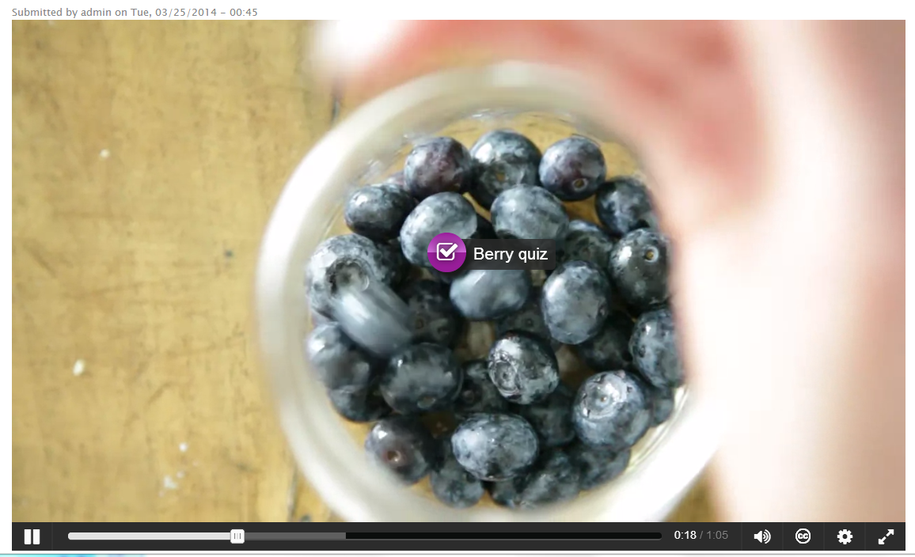
Fig. 1 Sample content by H5P
Adapt Learning
Adapt Learning is an open source project established by City & Guilds Kineo, Learning Pool and Sponge UK.[5] Adapt framework has the following features.

- Multi-device delivery –The framework uses JavaScript and HTML and as such offers the cross browser and platform compatibility. A single build of a course will work across all supported devices and browsers, so no need to create a desktop version and then multiple versions of a native app to accommodate different mobile operating systems.
- Ease of maintenance – keeping content current becomes less problematic if there is only one version being maintained. In addition, due to the ubiquity of the technology used to create Adapt Learning courses, the wider developer community will be able to work with the output.
- Future proof – the framework is designed from the ground up to run as well on a mobile device as it does on a desktop. This is sensible given recent trends, with mobile web browsing soon to overtake the desktop as the most common means of accessing the internet. There is also a similar trend with the hardware being purchased, with mobile devices already outstripping the desktop in many markets.
- Accessibility ‘out of the box’ – Courses created in Adapt Learning are fully accessible with no need for a separate version to comply with DDA guidelines.

Figure 2 is the sample content authored using Adapt learning framework.

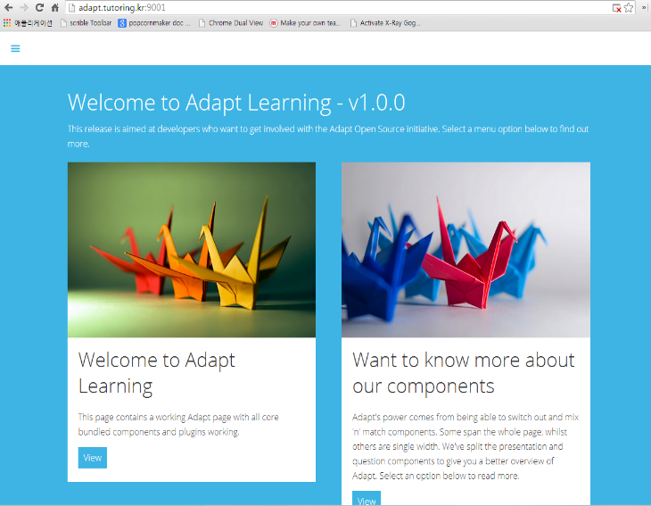
Fig. 2 Sample content by Adapt Learning

Adapt framework uses components instead of templates. Pages are constructed by combining a wide range of interactive components in any number and mix required.
The Adapt authoring tool is a web-based authoring environment aimed at non-technical end users. It enables users to create responsive design e-learning content using the Adapt Framework.
The Adapt authoring tool is currently in development phase and it is expected that version 0.1 will be released during 2014.
3. Flipped Classrooms

Some traditional schools blend online and offline learning, sometimes called flipped classrooms. Students watch lectures online at home and work on projects and interact with faculty while in class. Such hybrids can even improve student performance in traditional in-person classes. One fall 2012 test by San Jose State and edX found that incorporating content from an online course into a for-credit campus-based course increased pass rates to 91% from as low as 55% without the online component.[6]
Traditionally, each topic in class receives a fixed amount of time for all students. Students who do not master the material get no extra time. Mastery learning upends this approach, by requiring each student to master the topic before moving to the next one. Flipped mastery learning applies the mastery concept to flipped classrooms.
Mastery learning was briefly popular in the 1920s, and was revived by Benjamin Bloom in 1968. The teacher provides materials, tools and support. Students set goals and manage their time.
Mastery rewards students for displaying competence. Students who initially turn in shoddy work must correct it before moving on. Before flipping, mastery learning was impractical in most schools. It was not possible to give different lectures for different groups of students. Testing was also impractical, because fast-learning students could reveal the test to those who followed.
In a flipped mastery classroom, students view each lecture and work on each exercise or project when they have mastered the precursors.
Flipped mastery eliminates two other out-of-class routines: daily lesson planning and grading papers. The latter happens in class and in person. Replacing lectures with group and individual activities increases in-class activity. Every student has something to do throughout the class. In some classes, students choose how to demonstrate mastery - testing, writing, speaking, debating and even designing a related game. Moodle provides one way to manage the testing process. It creates a different test for each student from a pool of questions. Advocates claim that its efficiency allows most students to do a year’s work in much less time. Advanced students work on independent projects while slower learners get more personalized instruction. Some students might not get through the year’s material, but demonstrated competence on the parts they did complete.
For flipped classroom, teachers have to record their lecture and post it on LMS such as Moodle. Since Moodle does not provide recording functionality itself, teachers have to use other recording tools such as Camtasia Studio, Captivate. Smart phone can be used for real-time lecture recording. The recorded video can be served via Youtube or a video server. Video servers based on open source Kaltura may be utilized for encoding video and management.
Assessment and feedback can be partially automated using Moodle’s quiz activity.

4. MOOC

MOOCs are hot topics in e-learning which began popular in 2012. Assessment can be the most difficult activity to conduct online, and online assessments can be quite different from the bricks-and-mortar version. Special attention has been devoted to proctoring and cheating.
A study of edX student habits found that certificate-earning students generally stop watching videos longer than 6 to 9 minutes.[7]
Peer review is often based upon sample answers or rubrics, which guide the grader on how many points to award different answers. These rubrics cannot be as complex for peer grading as for teaching assistants. Students are expected to learn via grading others and become more engaged with the course. Exams may be proctored at regional testing centers. Other methods, including "eavesdropping technologies worthy of the C.I.A." allow testing at home or office, by using webcams, or monitoring mouse clicks and typing styles.

The two most common methods of MOOC assessment are machine-graded multiple-choice quizzes or tests and peer-reviewed written assignments. Machine grading of written assignments is also underway. Table 1 shows the list of MOOC providers.

Table1. MOOC provider and institutional participants

Provider | Type | Example institutional participants
Coursera | Commercial | University of Maryland, Wharton School, University of Virginia, Stanford University, University of Tokyo
iversity | Non-profit | Universidad Autonoma de Madrid, University of Florence, University of Hamburg
edX | Non-profit | MIT, Harvard University, UC Berkeley, Kyoto University, Australian National University, University of Queensland
Canvas Network | Commercial | Santa Clara University, University of Utah, Université Lille 1
OpenLearning | Commercial | University of New South Wales, Taylor's University, University of Canberra
Udacity | Commercial | Georgia Institute of Technology
Academic Earth | Non-profit | UC Berkeley, UCLA, University of Michigan, Oxford University
FutureLearn | Non-profit | University of Reading, Open University, Monash University, Trinity College, Dublin, Warwick University, University of Bath
Peer to Peer University | Non-profit | n/a
Khan Academy | Non-profit | n/a
Acade.me | Commercial | Universidad Latina
Saylor.org | Non-profit | n/a
Udemy | Commercial | n/a
MOOEC | Non-profit | University of Queensland, Griffith University, University of Technology
Novoed | Commercial | Stanford University, Carnegie Foundation, Universidad Católica de Chile
WizIQ | Commercial | IIT Delhi, Des Moines Area Community College

5 E-Learning Standards
There have been many e-learning standards to promise and deliver interoperability as well as reusability, durability, and accessibility. Standards specific to computer-based training and online learning have been around for years, though general adoption of these standards has been slow.
The aviation industry was one of the first to formulate standards. The Aviation Industry CBT Committee, AICC for short, defined a specification for interoperability between CBT courses and computer-managed instruction (CMI) record keeping systems. The AICC' CMI Guidelines for Interoperability presents a standard syntax and application programming interface (API) for communication between courseware and CMI. Though not widely adopted outside government and commercial aviation circles, the pioneering work of this committee set the stage for standards to follow.
The e-learning standards such as IEEE LOM, SCORM, IMS package standard, etc are diverse and difficult to apply. The diversity and difficulty of e-learning standards add burden to content developers and publishers. Furthermore, the e-learning standards have a problem in interoperability with the standards for library and repository. The standards for library and repository are mainly based on Dublin Core Metadata.
To solve the interoperability problem between IEEE LOM and Dublin Core, The ISO/IEC 19788 standard was proposed.

ISO/IEC 19788

ISO/IEC 19788 Information technology - Learning, education and training - Metadata for learning resources is a multi-part standard prepared by subcommittee SC36 of the Joint Technical Committee ISO/IEC JTC1, Information Technology for Learning, Education and Training. This committee was created to deal with the consequences of substantial overlap in areas of standardization done at the International Organization for Standardization (ISO) and the International Electrotechnical Commission.
The ISO 15836 Dublin Core (DC) and the IEEE 1484.12.1-2002 Learning Object Metadata (LOM) are widely used metadata standards to describe learning resources. Dublin Core metadata are mainly used for library system such as DSpace, while LOM based metadata are used for the description of learning objects. However, interoperability between DC metadata and LOM metadata is far from complete, only plausible practices are often implemented and used.
A DC Date element can be written in plain language and not processed by queries. Ambiguous definitions pose another challenge as data elements and vocabulary values can be interpreted in a subjective way. For example the DC Date can be linked to resource creation time, update or publication. In the LOM, the Cost element can only have a “yes” or “no” values. This is also true for LOM records as they are based on a wide variety of Application profiles. The ISO/IEC 19788 standard is intended to provide optimal compatibility with both DC and the LOM and supports multilingual and cultural adaptability requirements from a global perspective. The standard has two primary purposes:
1) To facilitate the identification and specification of the metadata elements required to describe a learning resource by providing metadata elements and their attributes
2) To support search, discovery, acquisition, evaluation, and use of learning resources by learners, instructors or automated software processes.
To avoid ambiguity and provide interoperability, metadata learning resources (MLR) data elements are documented using attributes: 1) Identifier, 2) Property name, 3) Definition, 4) Linguistic indicator, 5) Domain, 6) Range, 7) Content value rules, 8) Refines, 9) Example(s), 10) Note(s).
The multi-part standards of ISO/IEC 19788 are shown in Figure 3. The basic parts of the standard are already published, namely the framework that is freely available from ISO (part 1), the list of Dublin Core elements (part 2), an associated application profile (part 3) and a set of pedagogical elements (part 5). A working draft of Bindings (part 7) can be found on the GTN-Quebec standard workgroup site. As of June 2014, only parts 1, 2, 3 and 5 are released as international standards. The other parts are still under development. It is not known when all the standards will be finalized.
Metadata can be expressed in RDF (Resource Description Framework). Assertions about a learning resource are made using triples (subject, predicate, object) where subject represents the learning resource, predicate is a property identifier and object is the property value.

Subject: ISBN 0-262-18162-2
Predicate: ISO_IEC_19788-2:2011::DES0100
Object: Turtle, Termites, and Traffic Jams@en

In a MLR triple, the subject is always the literal of an identifier of the learning resource, such as a URI or ISBN. The predicate is also a literal, the MLR data element specification (DES) identifier.

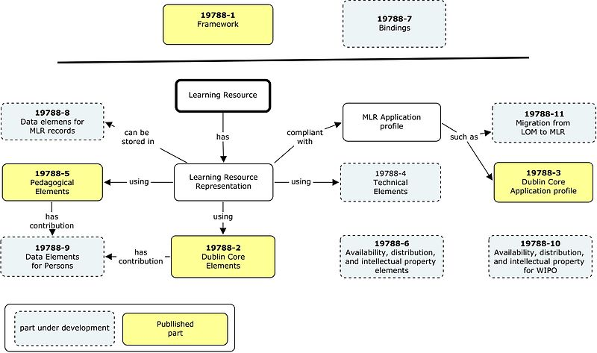
Fig. 3 The multi-part standards of ISO/IEC 19788

Computers can easily connect and query linked data structured information. For example, a teacher wishing to annotate a learning resource may do it a single RDFa triple.
A repository service can gather all the information about a given learning resource from a wide variety of external sources, providing much richer information than a single provider record.

Experience API

The Experience API (xAPI) provides a means to store and access data about learning experiences[8]. The xAPI is designed to support existing browser-based capabilities such as the Sharable Content Object Reference Model (SCORM) and extend that support to include non-browser-based capabilities such as mobile applications, games, virtual environments, full-scale simulators, and sensors. The xAPI also allows for much more granular data to be collected, such as learner progress, virtual media, and even real-world experiences. The xAPI introduces the concept of a learning record store (LRS) to create a “learning experience tracking service.” This store is a database of learning records that can be accessed by other systems, such as reporting applications, human resources programs, a learning management system, or any other authorized system.
The xAPI uses a format for the learning record similar to activity streams used in social media. The format can be thought of as a simple sentence with the structure, <actor><verb><object>: “Bob viewed video” or “Mary read book.” The standard also is meant to accommodate speciﬁc details: “Bob viewed [learning fractions] video” or “Mary read [The Autobiography of Miss Jane Pittman] book.”
The learning record can infer information based on previously stored data. (A book is read; a video is viewed.) The data contained in those learning records can also be used to build up, assign, or sequence activities for learners: After somebody has written a chapter, for example, another learner can be told to edit it, a third to proof it, and a fourth to add it to an existing chapter. These capabilities allow the xAPI to be used to recommend content, tailor learning experiences, and provide instructor feedback on content or learner assessments.
The xAPI is meant to be “stacked” with other technologies for value-added services. For example, the xAPI can track extremely granular data in several learning record stores, which can then be conﬁgured to sync up with data from other technologies like in Bloom or the Open Badges Infrastructure. The xAPI can be used to track usage data of content or sub-components of content. This usage data can then be pushed to the Learning Registry or used by LRMI as valuable paradata for those searching for high-quality educational content. (“Which video on fractions was most assigned by other teachers in my district?”)
The xAPI provides a capability to store and access information from a diverse set of learning, training, and performance support experiences. Teachers can use this data to determine a student’s true understanding of a concept beyond basic summary data such as quiz or test scores. Systems can automatically tailor content based on a thorough understanding of a learner’s previous course history and interactions with learning content. Learners can choose to include informal and self-guided learning experiences into their learning record store that can later be used to help determine the impact of learning outside of formal curricula.[9]
Future plans include the creation of community-speciﬁc vocabularies or proﬁles that will enhance interoperability of content and systems. Sponsoring organization ADL will serve as a catalyst for additional xAPI proﬁles. In addition, xAPI tangential speciﬁcations for big data query interfaces, learner proﬁles, and activity deﬁnitions are all potential extension points.
The xAPI forms a building block for ADL’s eventual goal: to create a “personal assistant for learning” that can anticipate learner needs, integrate with relevant information, and provide access to personalized learning content.
The xAPI is a brand new specification for learning technology that makes it possible to collect data about the wide range of experiences a person has (online and offline). This API captures data in a consistent format about a person or group’s activities from many technologies. Very different systems are able to securely communicate by capturing and sharing this stream of activities using xAPI’s simple vocabulary. Previous specifications were difficult and had limitations (see xAPI vs SCORM), but xAPI is simple and flexible. It lifts many of the older restrictions. Mobile learning, simulations, virtual worlds, serious games, real-world activities, experiential learning, social learning, offline learning, and collaborative learning are just some of the things that can now be recognized and communicated well with the xAPI.[10]
6. Conclusions
E-learning is continuously evolving through flipped classroom, MOOC and new authoring tools. In this paper, we have discussed the current trends in e-learning community. Application of technology into learning and teaching become more deliberate, easy to use and humanized. The data about student’s response can be utilized for better application of technology into learning.
References
1. http://www.educause.edu/ero/article/think-exciting-e-learning-and-big-e
2. http://www.askinternational.com/knowledge/articles/eBasic/whatsElearn.html
3. http://c4lpt.co.uk/directory-of-learning-performance-tools/instructional-tools/.
4. http://h5p.org/
5. https://community.adaptlearning.org/
6. http://blogs.wsj.com/digits/2013/07/18/san-jose-state-pauses-udacity/
7. http://en.wikipedia.org/wiki/Massive_open_online_course.
8. http://tincanapi.com/.
9. http://classroom-aid.com/2014/05/29/xapi-forming-building-blocks-of-personal-assistant-for-learning/.
10. http://www.learningsolutionsmag.com/articles/1271/the-xapi-and-the-lms-what-does-the-future-hold.

